

**OLYMPICS DATA ANALYSIS AND PREDICTION SYSTEM**

**NAME:** Dhruv Dwivedi

**ROLL NO:** 2000100100062

**GROUP MEMBERS**

1. Dhruv Dwivedi (2000100100062)
2. Divyanshu Singh (2000100100064)
3. Anjali Kushwaha (2000100100028)
4. Charu Shukla (2000100100053)
5. Pragya Agrawal (2000100100122)

**DEPARTMENT OF COMPUTER SCIENCE**

**UNITED COLLEGE OF ENGINEERING AND RESEARCH, PRAYAGRAJ**

**DR. APJ ABDUL KALAM TECHNICAL UNIVERSITY,LUCKNOW**



**A-31, UPSIDC, Industrial Area, Naini, Prayagraj**

**Website: <http://www.united.ac.in>**

**ACKNOWLEDGEMENT**

I would like to extend my special gratitude to IIIT Faculties for their tremendous support and guidance all through the Summer Training by Engineer Core from IIIT Allahabad.

I would like to thank them once again for their dedication and commitment that ensured all my concepts were cleared without which I would not be able to finish this project.

**DECLARATION**

This is to declare that this report has been written by me. No part of the report is plagiarized from other sources. All information included from other sources have been duly acknowledged. I aver that if any part of the report is found to be plagiarized, I shall take full responsibility for it.

Dhruv Dwivedi (2000100100062)

**CERTIFICATE**

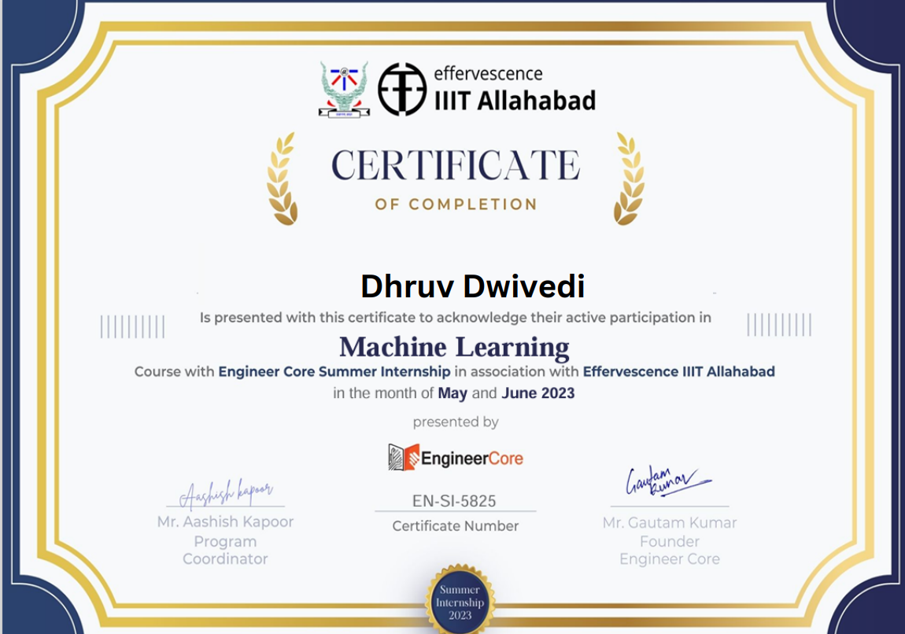

**TABLE OF CONTENTS**

1) Introduction

1.1 About Project

1.2 Project Description

1.3 Structure of Website

1.4 Technologies Used

2) Machine Learning

2.1 Scope of Machine learning

3) Project Implementation

4) Reference

5)Links

**INTRODUCTION**

The Olympic Games are a prestigious international sporting event held every four years, bringing together athletes from around the world to compete in a wide range of sports. The Games have a rich history dating back to ancient Greece, where they were held in Olympia from at least 776 BCE until they were abolished in 393 CE. The modern Olympic Games were revived in the late 19th century and have since become the largest and most celebrated multi-sport event in the world.

The Olympic Games serve not only as a platform for athletic competition but also as a celebration of global unity, cultural exchange, and the pursuit of excellence in sports. They continue to captivate audiences worldwide, fostering goodwill and friendship among nations.

**About Project**

An Olympics data analysis and prediction system analyse historical data related to the Olympic Games, athletes, and various sporting events. This system combines data analytics, machine learning techniques to provide valuable insights into athlete performance, trends, and potential outcomes.

The goal of an Olympic data analysis and prediction system project is to leverage data-driven insights to enhance the understanding of past performances, identify patterns, and make informed predictions about future outcomes in the context of the Olympic Games.

**Project Description**

The Olympics Data Analysis and Prediction System is a comprehensive project aimed at analyzing historical Olympic data and predicting outcomes for future events. This system combines data analytics, machine learning techniques to provide valuable insights into athlete performance, trends, and potential outcomes.

**Structure of Website**

**Home page**

Home page includes:

* Navigation links to other page like fixture, atheletes, analysis
* Featured atheletes
* Games
* Ticket bookings

**Ticket Generation**

Ticket Generation includes:

* Name
* Email
* Event
* Quantity

**Sign Up Page**

Sign Up page includes:

* Name
* Email
* Password
* Confirm Password

**Login Page**

Login Page includes:

* Email
* Password

**Featured Atheletes**

It includes atheletes of various games like:

* Softball
* Archery
* Badminton
* Basketball
* Boxing
* Hockey
* Gymnastics

**Games**

It includes description of various games like:

* Archery
* Badminton
* Boxing
* Wrestling
* Tennis
* Weightlifting
* Hockey

**Payment Page**

* Cardholder name
* Card holder email
* Card Number
* Expiry Date
* CVV
* Payment method

**Analysis**

It include analysis of 120 year old data

* Medal Tally
* Overall analysis
* Country wise analysis
* Athelete wise analysis

**Technologies Used**

1. HTML
2. CSS
3. BOOTSTAP
4. JAVASCRIPT
5. NODE JS
6. MONGODB
7. MACHINE LEARNING
8. DATA ANALYTICS
9. STREAMLIT

**MACHINE LEARNING**

[Machine Learning](https://www.geeksforgeeks.org/machine-learning/)is a branch of [artificial intelligence](https://www.geeksforgeeks.org/artificial-intelligence-an-introduction/) that develops algorithms by learning the hidden patterns of the datasets used it to make predictions on new similar type data, without being explicitly programmed for each task.

Machine learning is used in many different applications, from image and speech recognition to natural language processing, recommendation systems, fraud detection, portfolio optimization, automated task, and so on. Machine learning models are also used to power autonomous vehicles, drones, and robots, making them more intelligent and adaptable to changing environments.

**SCOPE OF MACHINE LEARNING**

Machine learning has a vast scope, and it is used in many different fields, including healthcare, finance, retail, and many others. Its scope is increasing every day as more and more companies adopt this technology to improve their business processes.

One of the primary applications of machine learning is in data analysis. Machine learning algorithms can analyze vast amounts of data and find hidden patterns and correlations that humans would not be able to detect.

**PROJECT IMPLEMENTATION**

**Snapshots**

**HOME PAGE**



**FIXTURE**

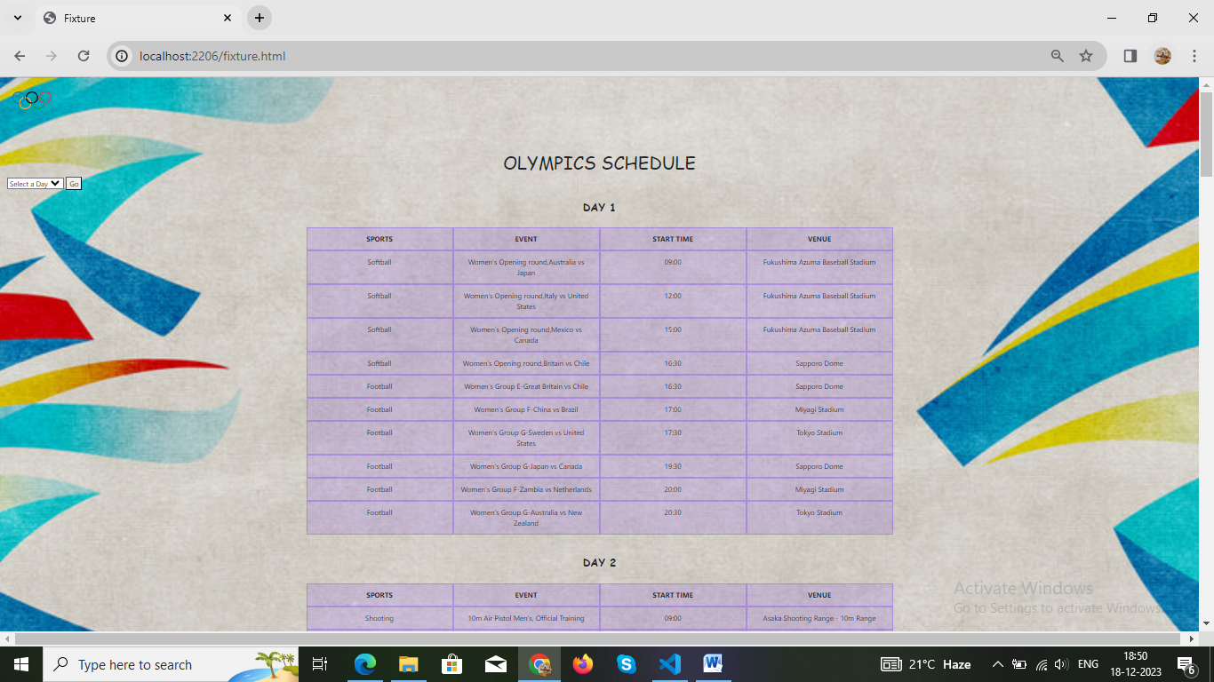

**LOGIN PAGE**

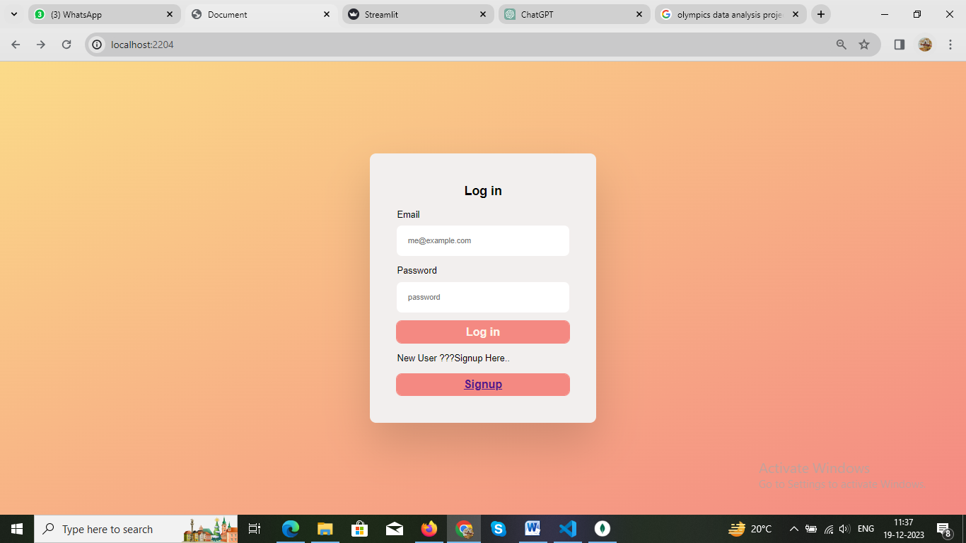

**SIGN UP PAGE**

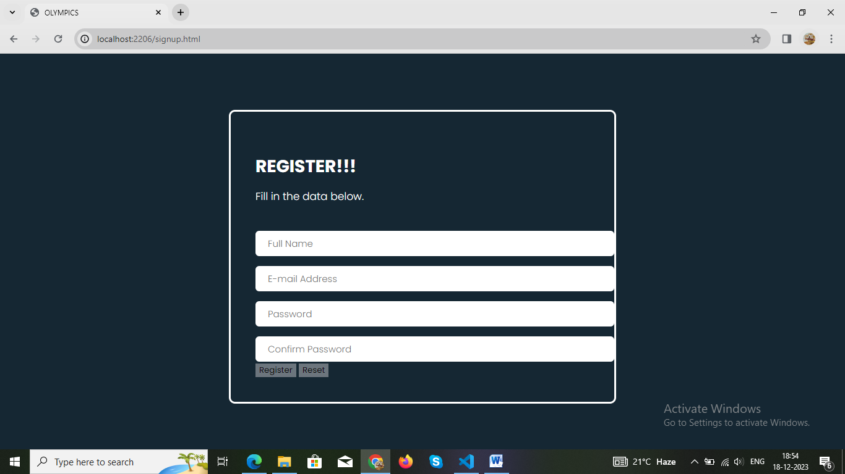

**Confirmation after signup**

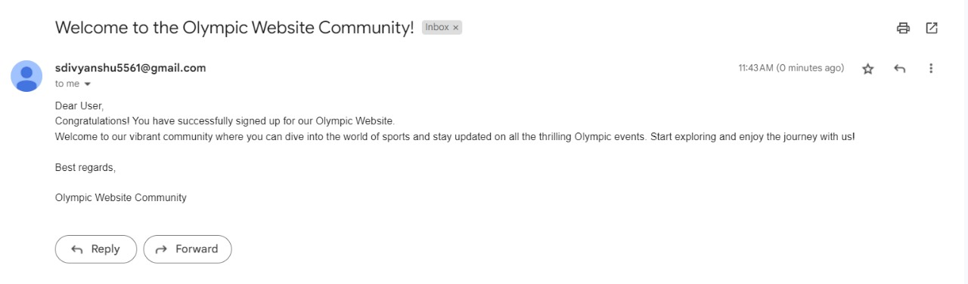

**ATHELETES**

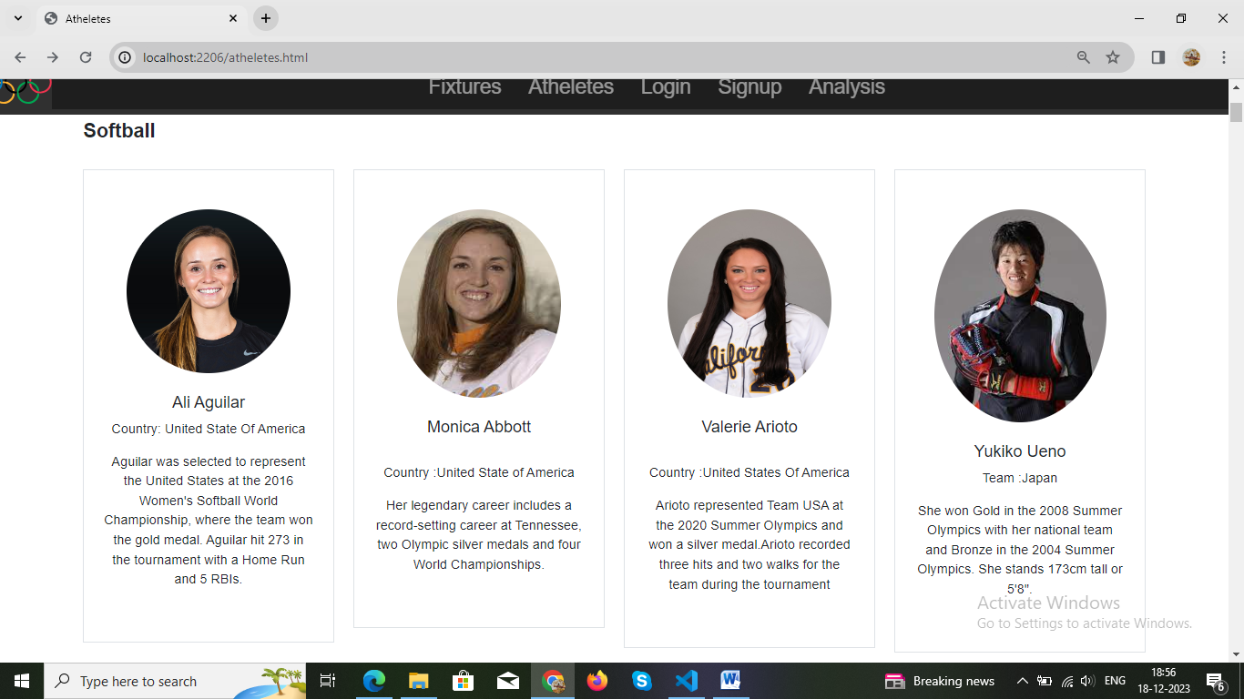

**ANALYSIS**

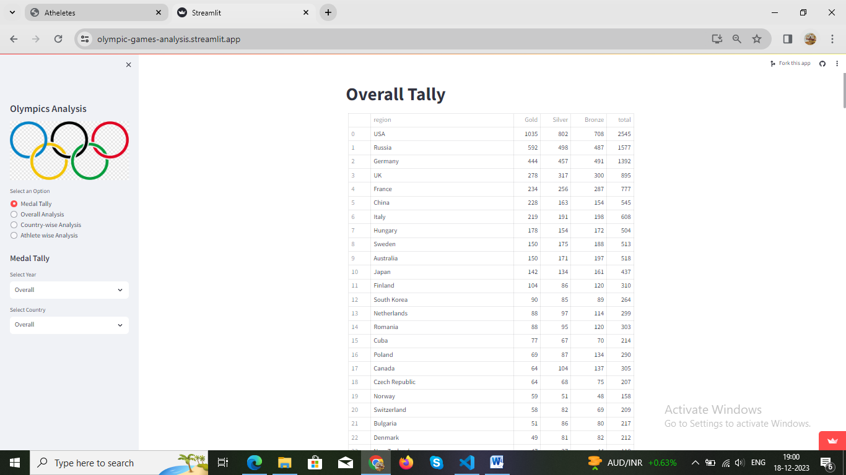

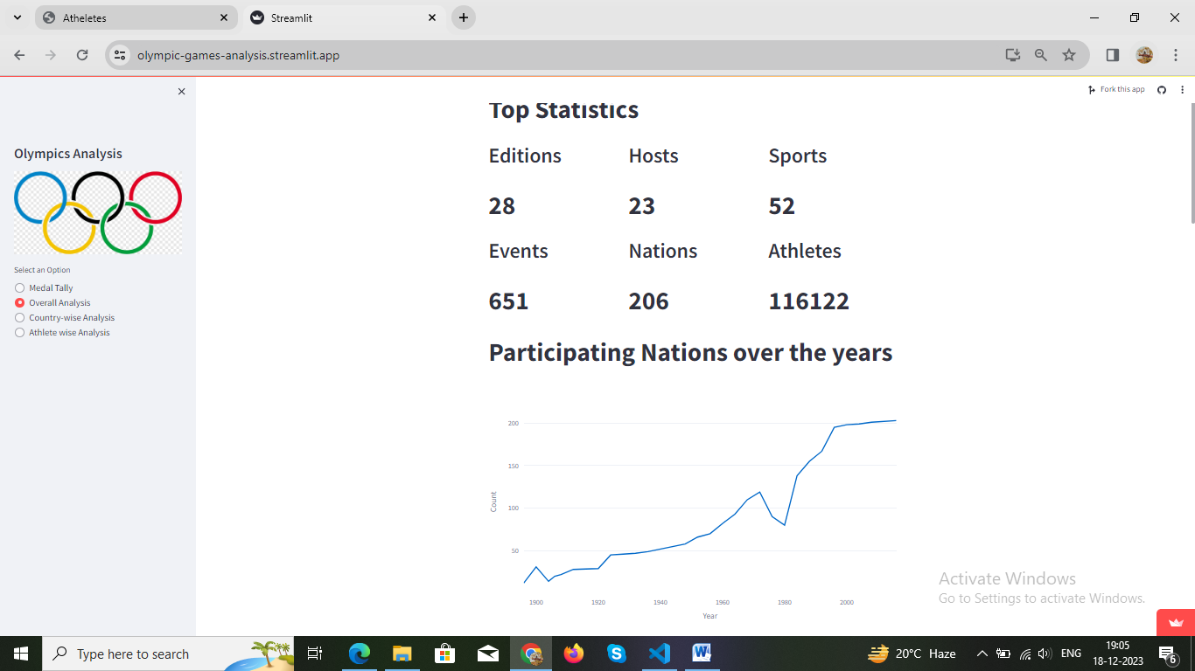

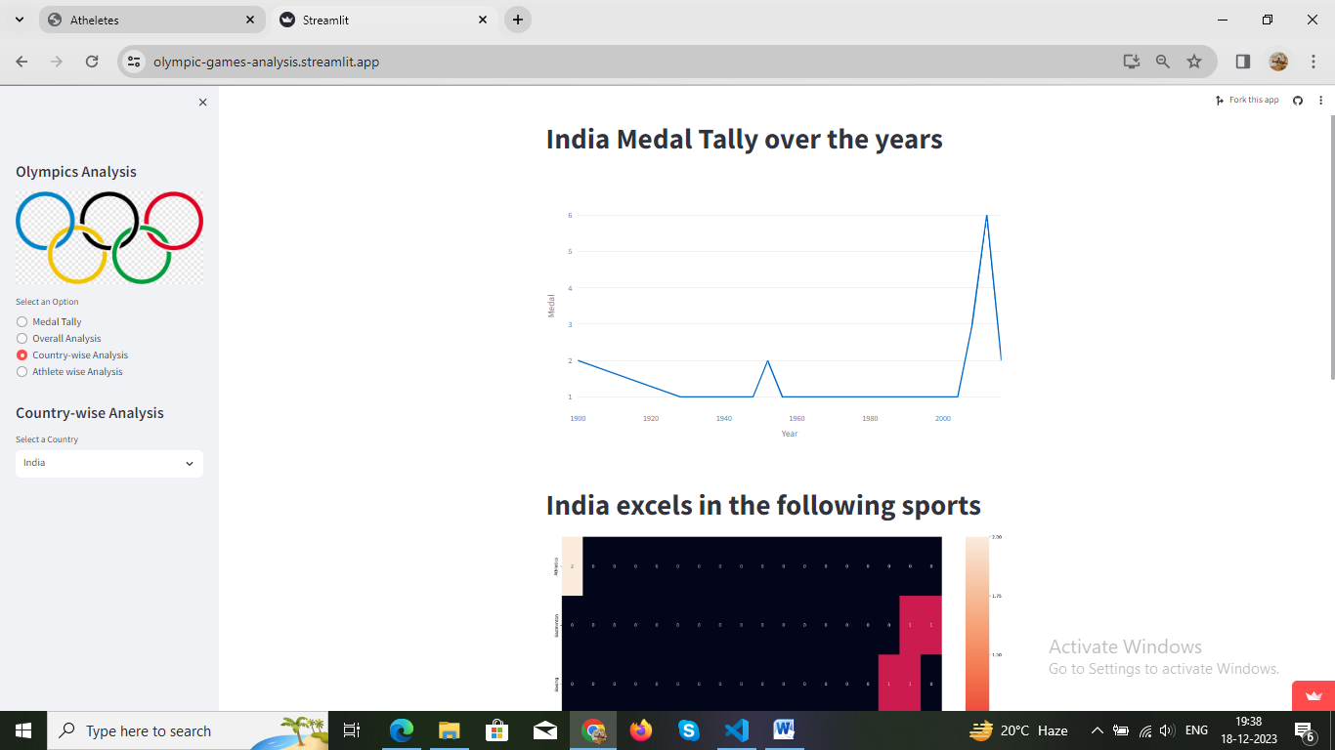

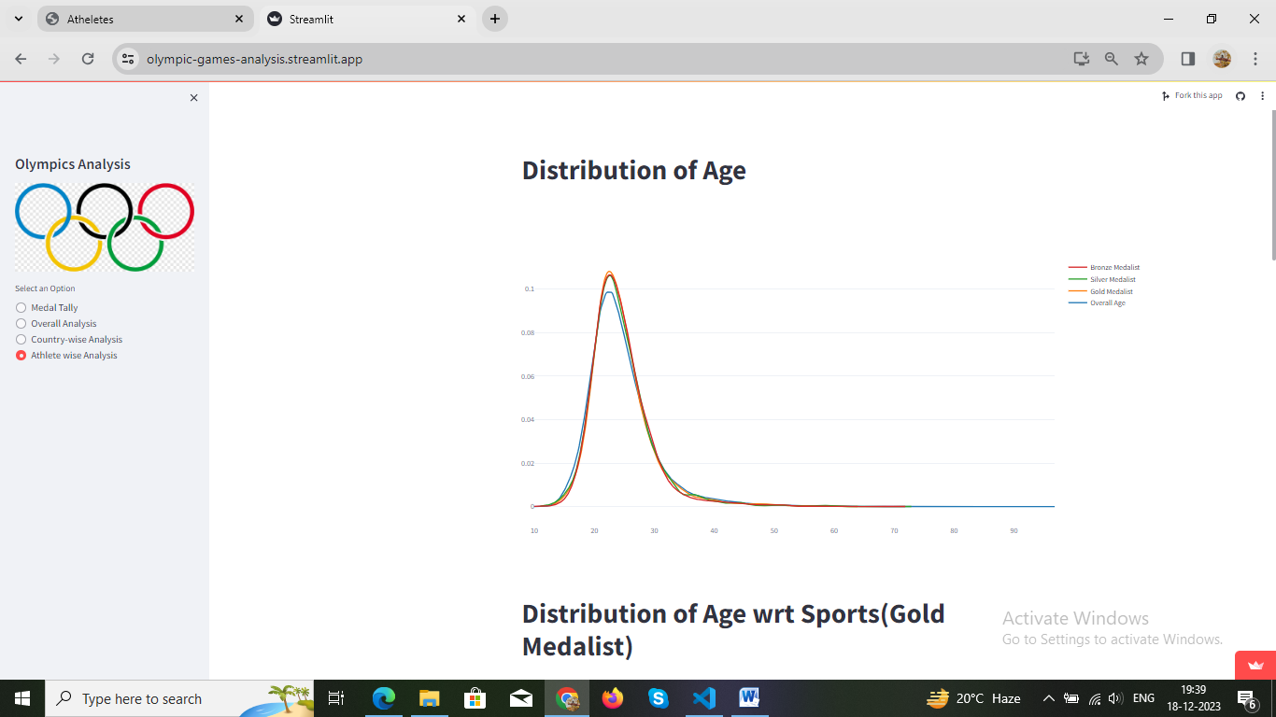

**Ticket Generation Page**

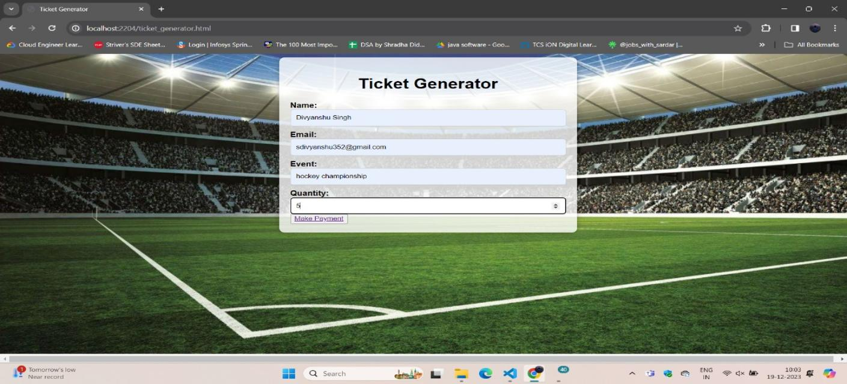

**Payment Page**

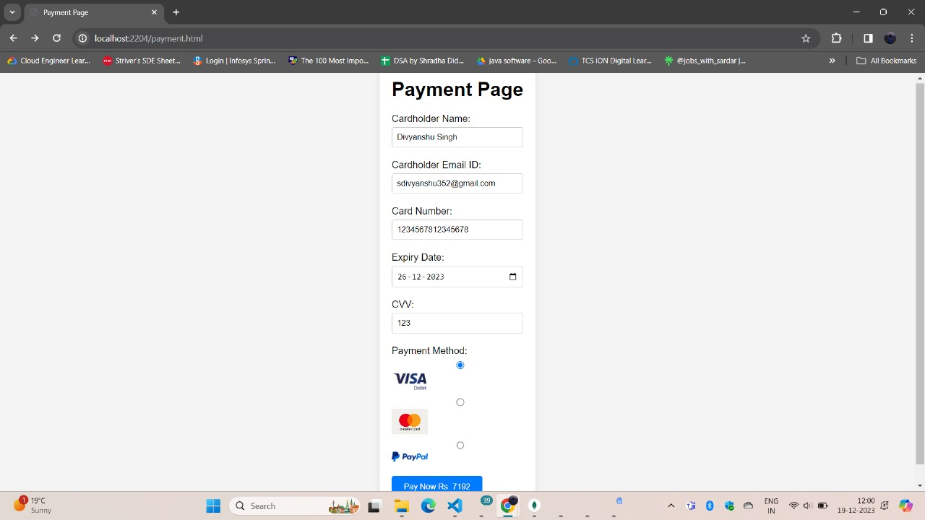

**Confirmation after payment**

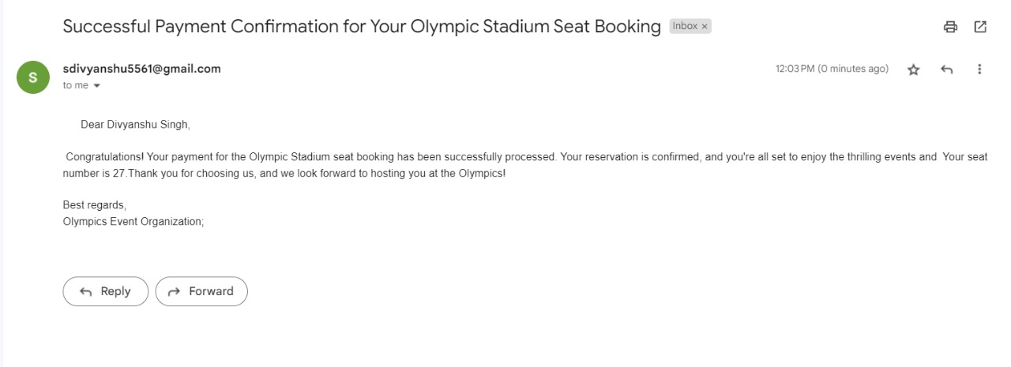

**DATABASE**

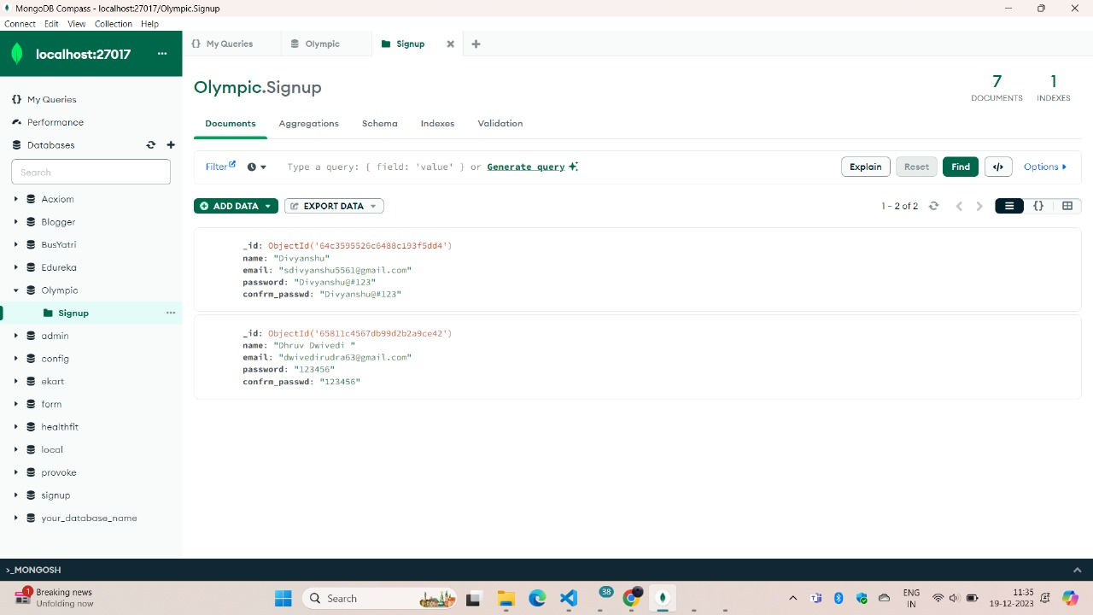

**PREDICTION**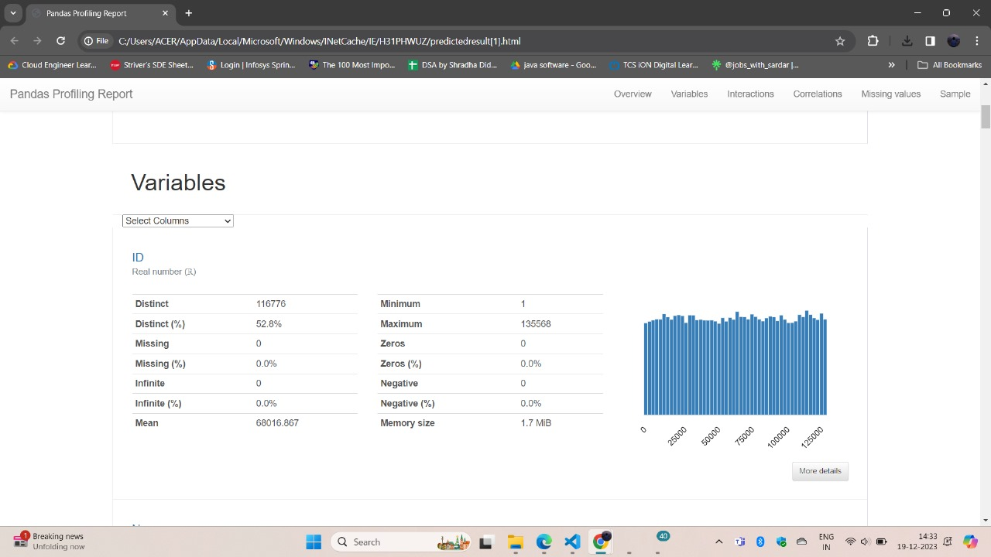

**REFERENCE**

1. GeeksforGeeks
2. Wikipedia
3. Javatpoint
4. W3schools

**LINKS**

* **<https://www.geeksforgeeks.org>**
* **<https://en.wikipedia.org>**
* **<https://www.javatpoint.com>**
* **<https://www.w3schools.com>**